Parking Space Occupancy Classification Using Machine Learning
Submitted By: P Bhavana

Internship: AlfidoTech – Machine Learning Internship

Task: Image Classification

Objective:
The objective of this project is to develop a supervised machine learning model that classifies parking spaces as Free or Occupied using annotated parking lot images. Two machine learning algorithms, Logistic Regression and Random Forest, are trained and compared using standard evaluation metrics

Dataset:
Dataset Source: Kaggle Parking Occupancy Dataset.
Category | Number of Images
Free | 273
Occupied | 624
Total | 897
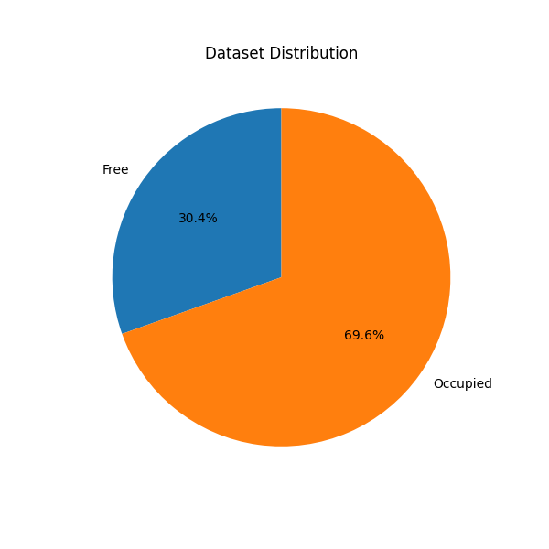

Dataset Description:
The dataset contains aerial images of parking lots along with XML annotation files indicating the location and occupancy status of each parking space.
Parking spaces were extracted from XML polygon annotations using OpenCV.

Data Preprocessing:
The following preprocessing steps were performed:

Parsed XML annotation files.

Extracted parking spaces using polygon coordinates.

Ignored partially occupied parking spaces.

Resized each extracted image to 32 × 32 pixels.

Converted images into feature vectors.

Assigned labels:

Free → 0

Occupied → 1

Train-Test Split:
The dataset was divided into:
Dataset | Samples
Training | 717
Testing | 180
Split Ratio:
- Training: 80%
- Testing: 20%

Model Development and Evaluation:

Logistic Regression:

Logistic Regression was used as the baseline classification model.
Results:
Metric | Value
Accuracy | 77.22%
Precision | 86.21%
Recall | 80.00%
F1 Score | 82.99%
ROC-AUC | 78.31%
Random Forest:
Random Forest was trained using 100 decision trees.
Results:
Metric | Value
Accuracy | 94.44%
Precision | 93.23%
Recall | 99.20%
F1 Score | 96.12%
ROC-AUC | 98.68%

Cross Validation:
5-fold Cross Validation was performed to evaluate the model's generalization performance.
Cross Validation Scores:
0.8278
0.9833
0.9553
0.9832
0.9330
Mean Cross Validation Accuracy:
93.65%
Performance Comparison:
Metric | Logistic Regression | Random Forest
Accuracy | 77.22% | 94.44%
Precision | 86.21% | 93.23%
Recall | 80.00% | 99.20%
F1 Score | 82.99% | 96.12%
ROC-AUC | 78.31% | 98.68%
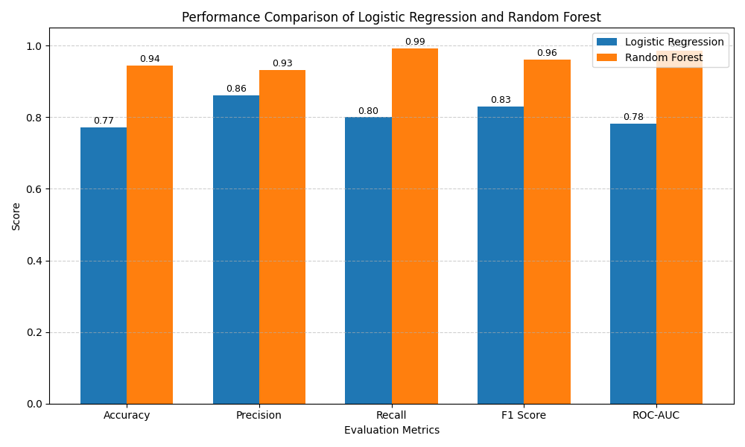

Confusion Matrix:
The confusion matrix illustrates the classification performance of the Random Forest model.
- True Negatives: 46
- False Positives: 9
- False Negatives: 1
- True Positives: 124
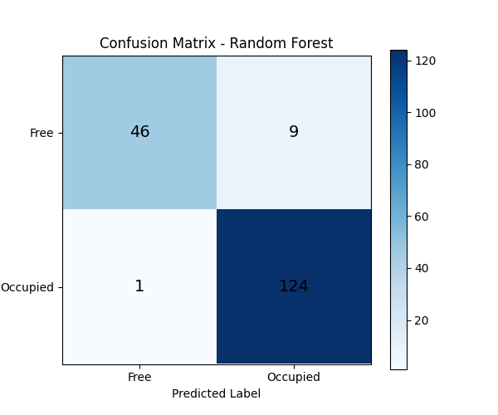
ROC Curve:
The ROC curve evaluates the model's ability to distinguish between free and occupied parking spaces.
ROC-AUC Score:
98.68%
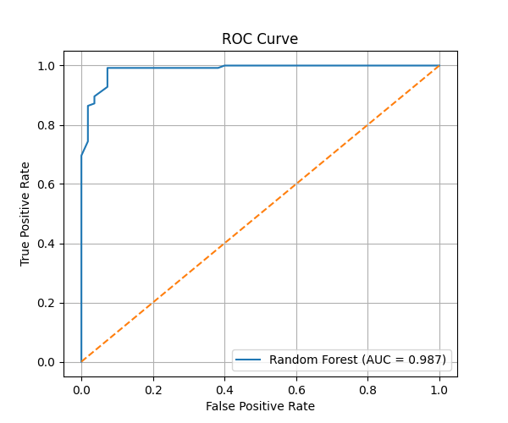

Conclusion:

Two supervised machine learning algorithms were evaluated for parking space occupancy classification.
Random Forest significantly outperformed Logistic Regression across all evaluation metrics, achieving:
- Accuracy: 94.44%
- Precision: 93.23%
- Recall: 99.20%
- F1 Score: 96.12%
- ROC-AUC: 98.68%
The high cross-validation accuracy (93.65%) demonstrates that the model generalizes well to unseen data. Therefore, Random Forest was selected as the final model for this project.
Tools & Technologies
- Python
- OpenCV
- NumPy
- Pandas
- Scikit-learn
- Matplotlib
- Visual Studio Code

